**🡪Order of Concepts before going to Bean Scopes:**

Singleton concept

Class Loaders concept

Phases of Class Loaders

Name Spaces of Class Loaders

JEE Class Loaders

CNFE & NoclassDefFoundError & LinkageError

When we need to make a class as singleton

== operator, equals() and hashCode()

Portal Applications

Bean Scopes

**🡪Portal Applications:**

As like we have Jsp pages we have portal pages.

🡪Purpose of Portal pages

Portal page contains the data by gathering the data form various different systems which are meant for aggregating (connecting) to various systems data in one single page.

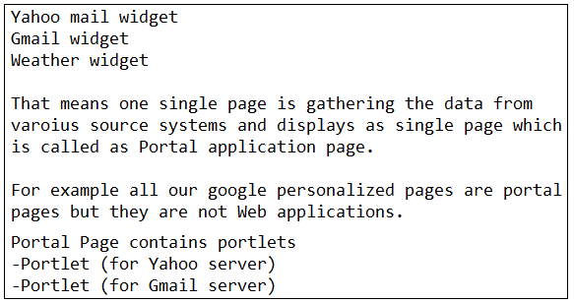

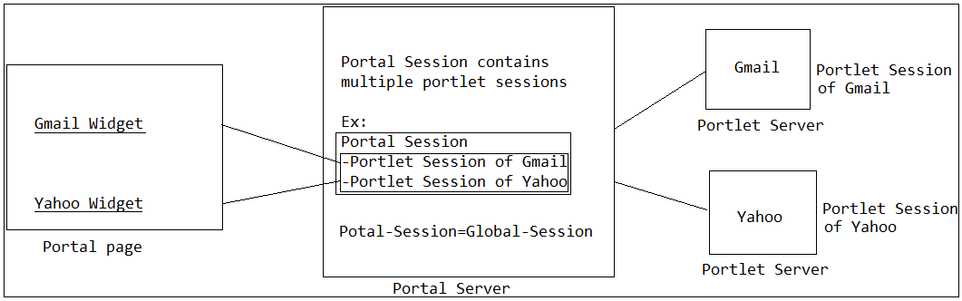

**🡪Bean Scopes:**

🡪Purpose of Bean Scope:

When we declare a class as a bean in spring-bean-config file then IOC-Container is going to create the obj for bean and manages the life cycle of an obj and bean-scope specifies/indicates to the IOC-Container how many obj’s has to be created for an bean that we declare as part of the spring-bean-config file.

Singleton

Prototype

Request

Session

Global-session

🡪Global session will not be applicable for Web applications rather it can be applicable for only Portal applications that’s where as part of Spring 3.0 global session has been deprecated the Global session and has been removed bcz portal application now a days not much popular or portal applications are out dated no one using now a days.

🡪So now we have only 4-scopes like singleton, prototype, request, session scopes only.

Ex:

class A {

}

<bean id= "a" class= "A">

**(OR)**

<bean id= "a" class= "A" scope="singleton">

A a1=factory.getBean("a",A.class);

A a2=factory.getBean("a",A.class);

a1==a2🡪true (Same obj)

<bean id= "a" class= "A" scope="prototype">

A a1=factory.getBean("a",A.class);

A a2=factory.getBean("a",A.class);

a1==a2🡪false (both are different objs)